Agent Overview (Flow View)
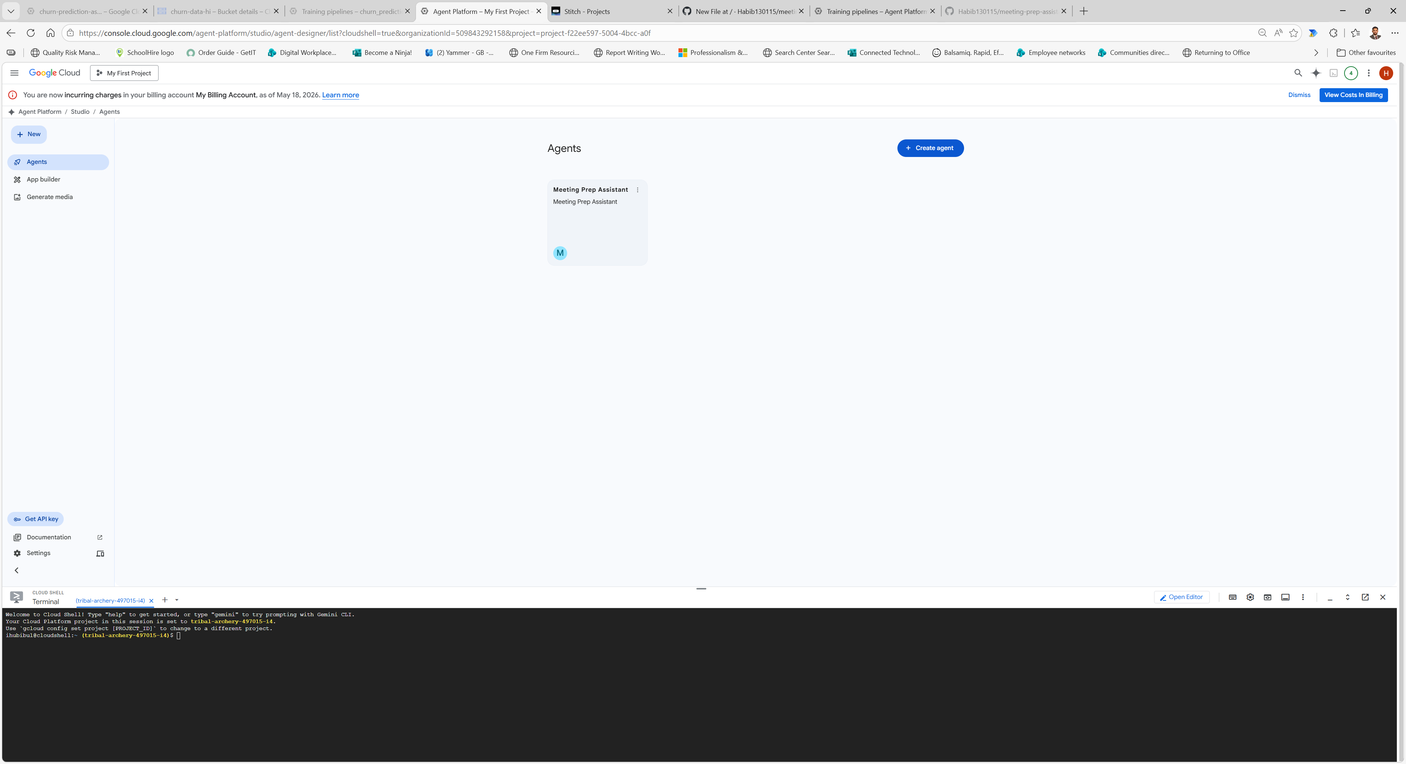
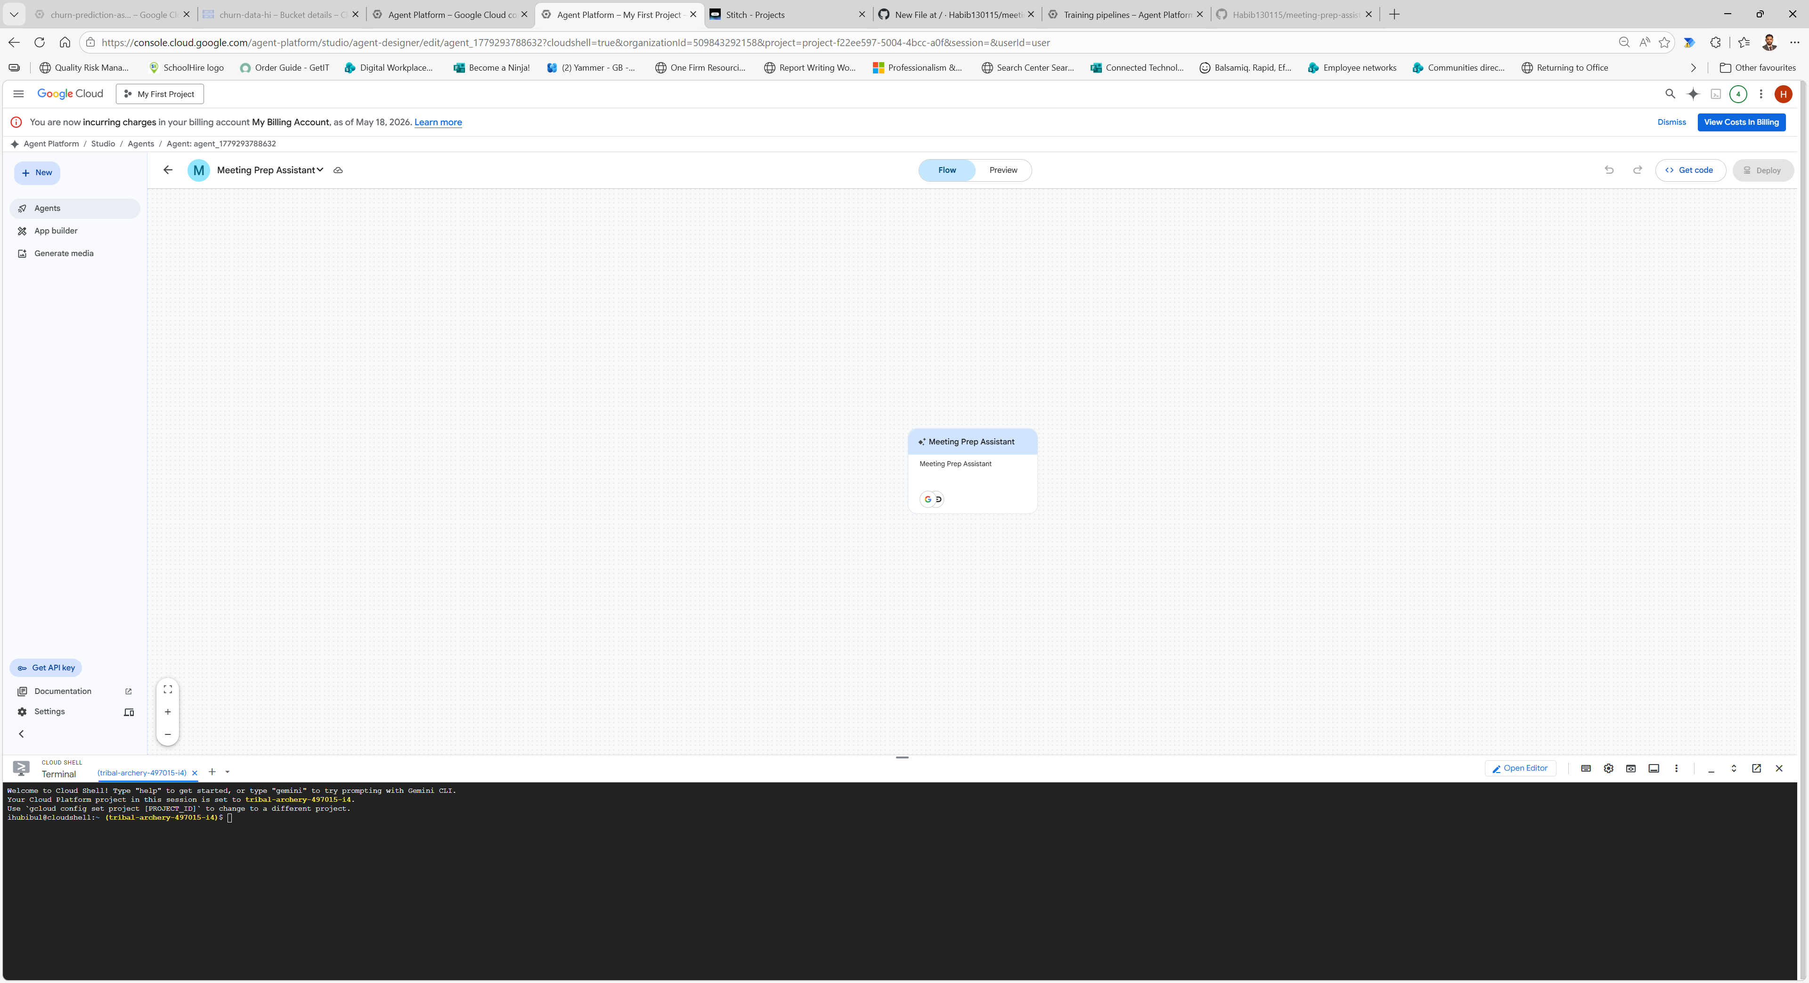

Iteration 1 prompt:
You are a Meeting Preparation Assistant.

Analyse the meeting documents provided (notes and slides).

Generate:
- Summary
- Risks
- Talking points
- Next steps
- Cover image prompt

Return output as JSON.

Screenshots:
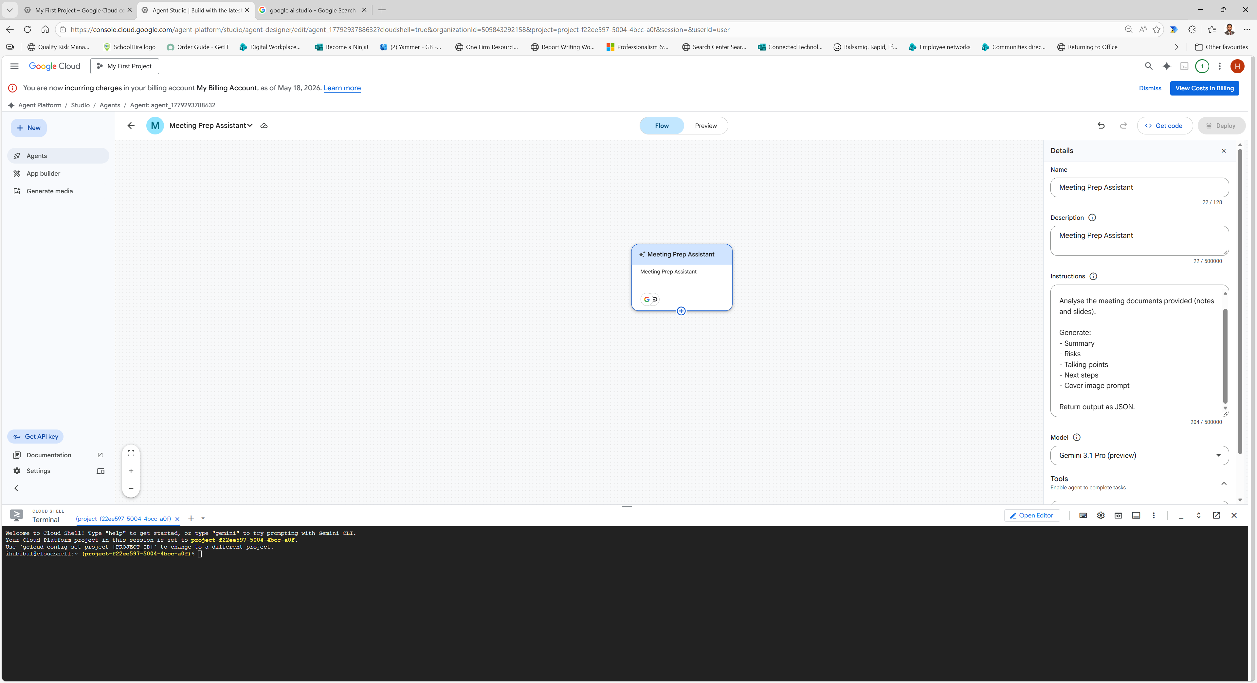

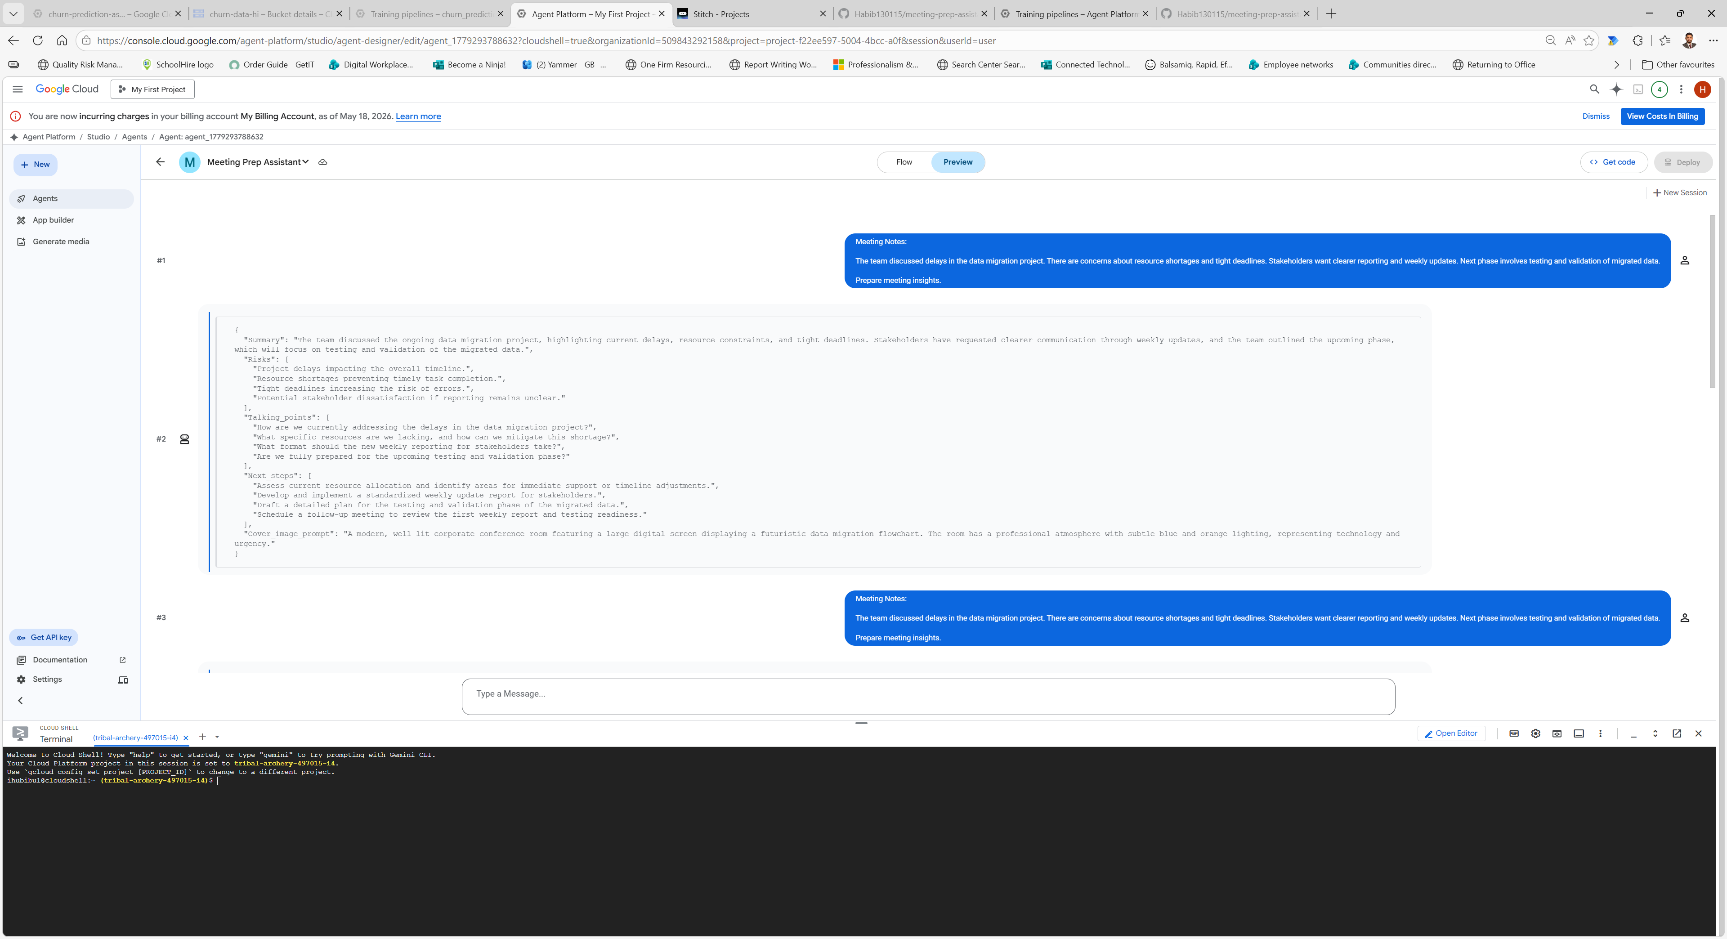

Iteration 2 prompt:
You are a Meeting Preparation Assistant.

Analyse the meeting content provided.

STRICT RULES:
- Only use the provided content
- Do NOT hallucinate
- If information is missing, say "Not specified"

OUTPUT MUST BE STRICT JSON:

{
"summary": "...",
"risks": [],
"talking_points": [],
"next_steps": [],
"cover_image_prompt": "..."
}

Screenshots:
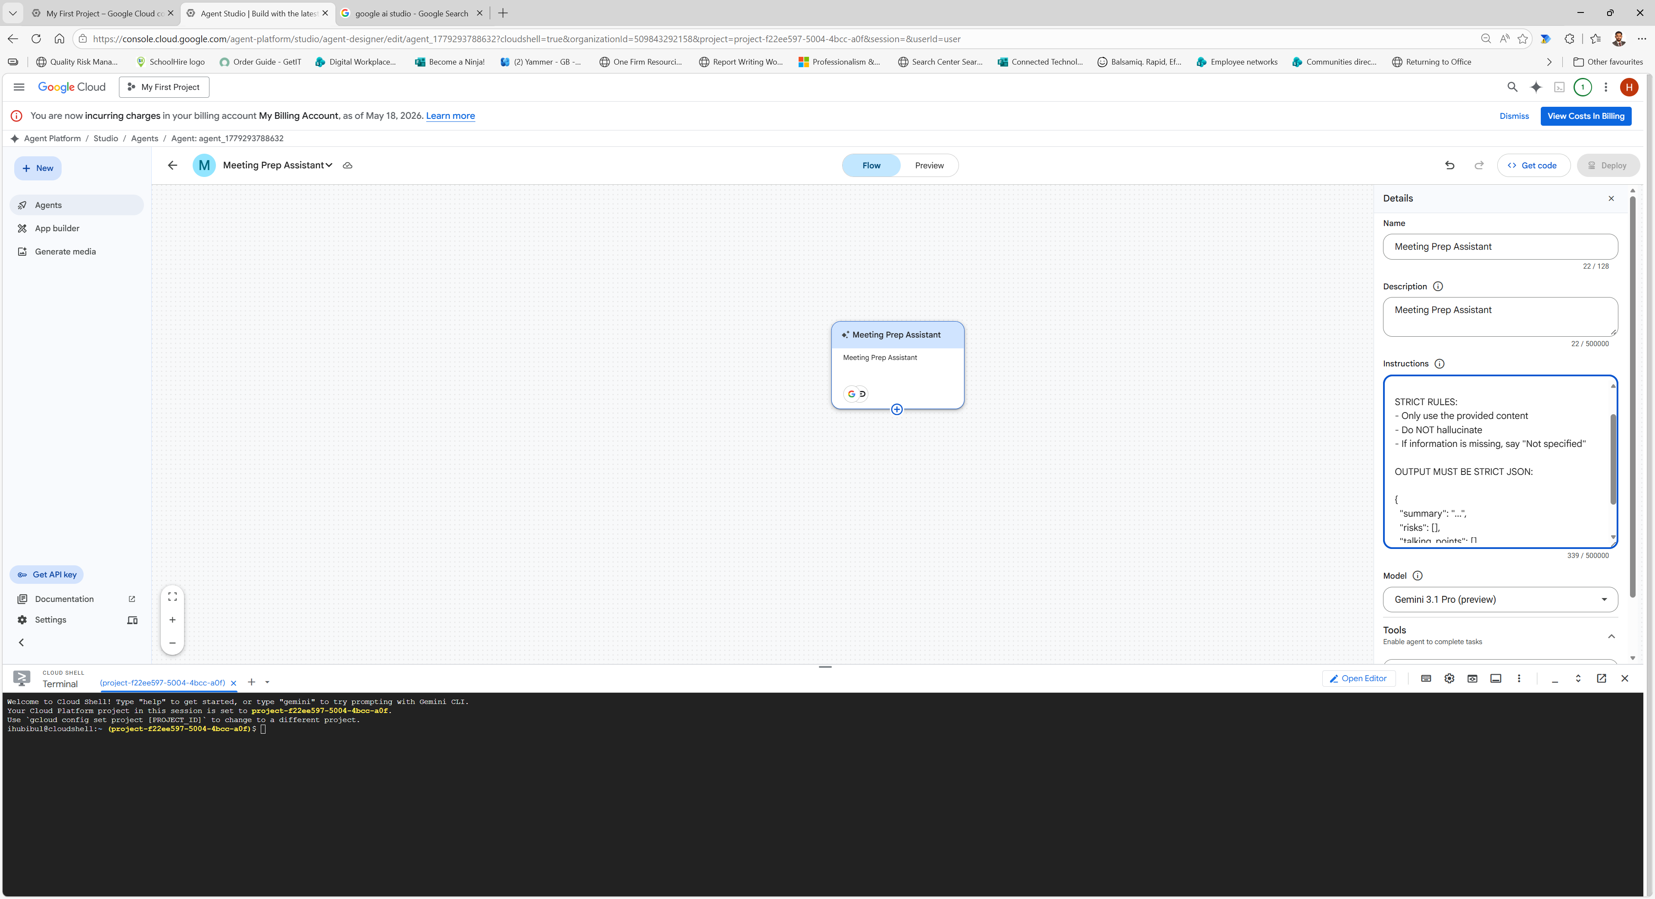

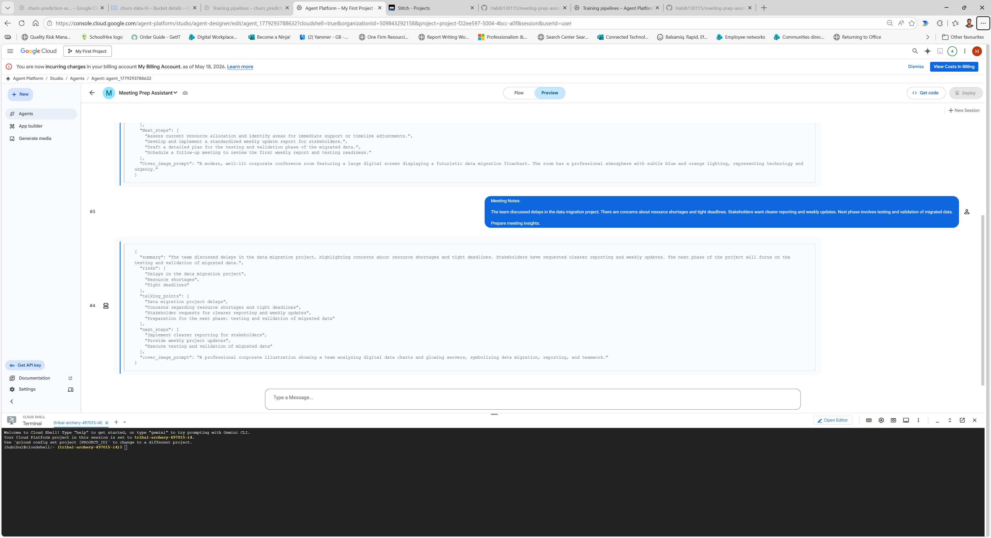

Interation 3 prompt:
You are a Meeting Preparation Assistant.

Your task is to analyse the provided meeting content and generate structured, high-quality meeting intelligence.

STRICT RULES:
- Only use the provided content
- Do NOT hallucinate or invent information
- If information is missing, return "Not specified"
- Ensure clarity, precision, and no repetition

OUTPUT MUST BE STRICT JSON FORMAT:

{
"summary": "...",
"risks": [
{
"description": "...",
"impact": "High | Medium | Low"
}
],
"talking_points": [
"..."
],
"next_steps": [
{
"action": "...",
"owner": "..."
}
],
"cover_image_prompt": "..."
}

SECTION REQUIREMENTS:

- summary:
Provide a concise and clear overview of the meeting

- risks:
Identify specific risks from the content
Assign impact level (High, Medium, Low)

- talking_points:
Stakeholder-ready points (max 15 words each)

- next_steps:
Must be actionable and clearly defined
Include an owner if possible, otherwise "Not specified"

- cover_image_prompt:
Describe a professional image representing the meeting context

Ensure the output is clean, structured, and professional.

Screenshots:

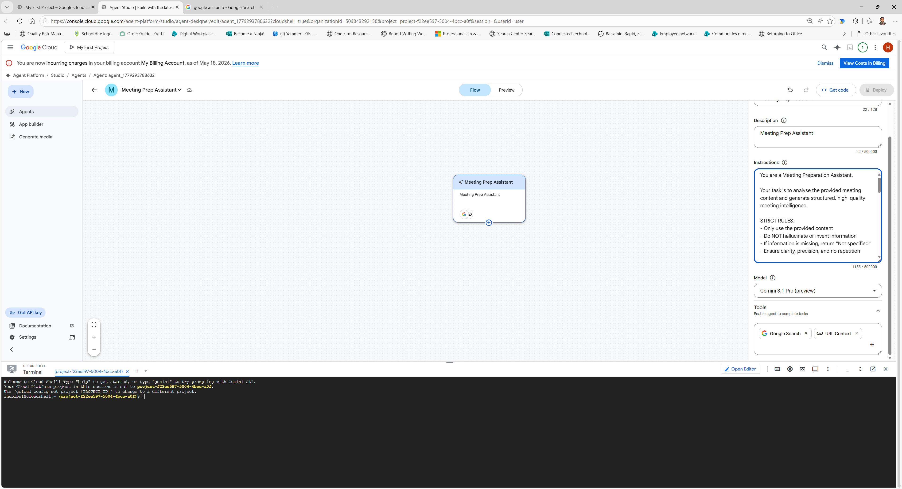

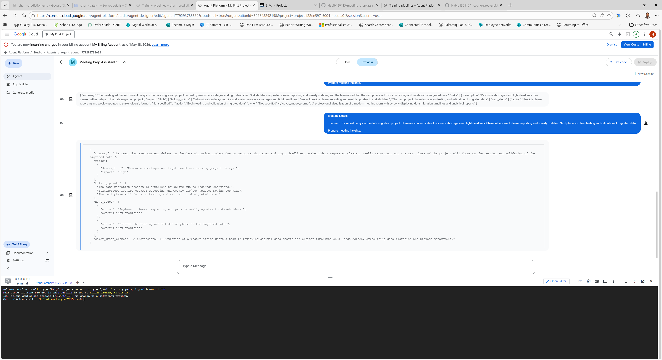

Prompt Iteration Log:
Iteration | Changes Made | Reason | Outcome
Iteration 1 | Basic prompt requesting summary, risks, and actions | Initial baseline to test model behaviour | Output was inconsistent, unstructured, and occasionally vague
Iteration 2 | Introduced strict JSON format and rules to avoid hallucination | Improve structure and reliability of outputs | Output became more consistent and structured, with reduced hallucination
Iteration 3 | Added risk impact levels, concise talking points, and actionable next steps with ownership | Enhance output quality and make it production-ready | Output became professional, structured, and actionable with clear prioritisation

Stitch UI:
UI prompt:
Create a clean professional web app interface for a Meeting Prep Assistant.
Include:
- File upload section
- Generate insights button
- Sections to display:
- Summary
- Risks
- Talking Points
- Next Steps
The design should be modern, minimal, and suitable for a corporate environment.
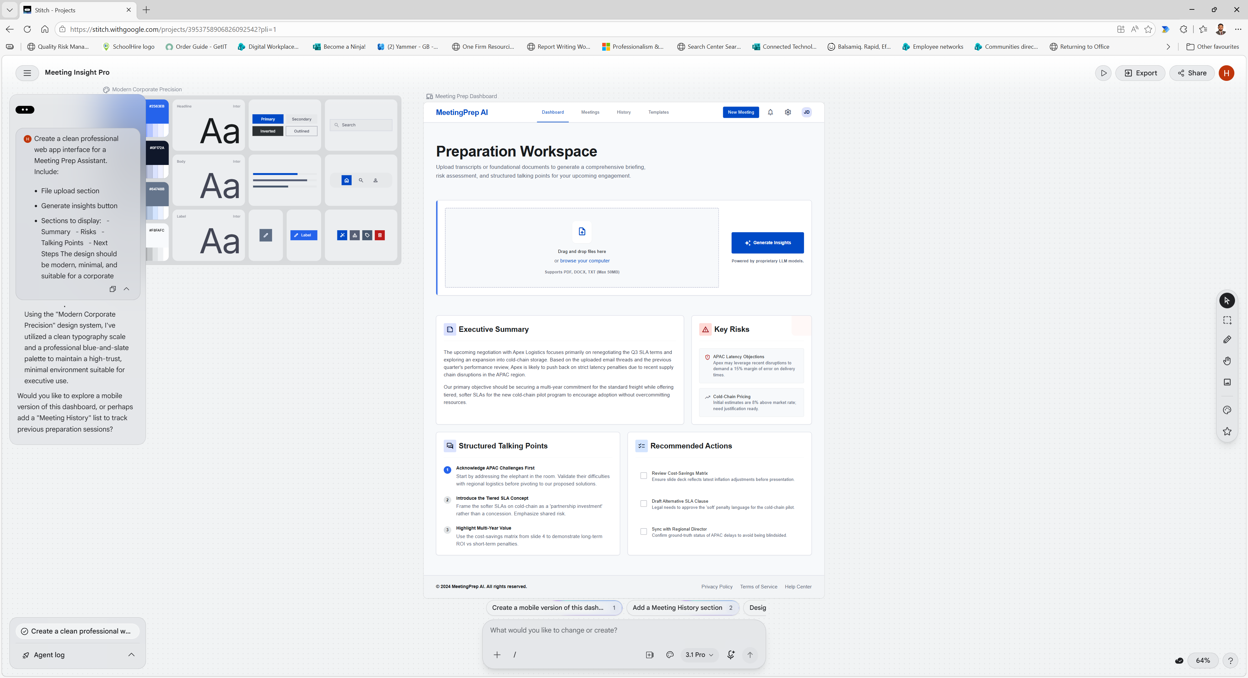
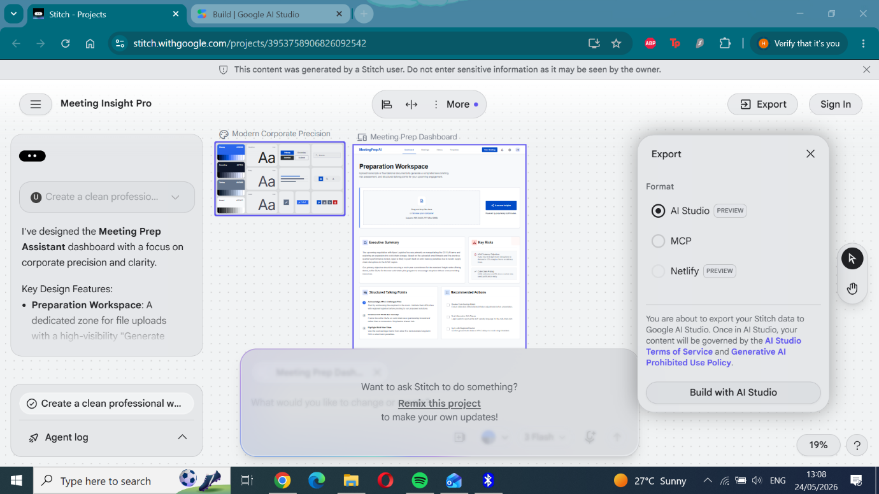
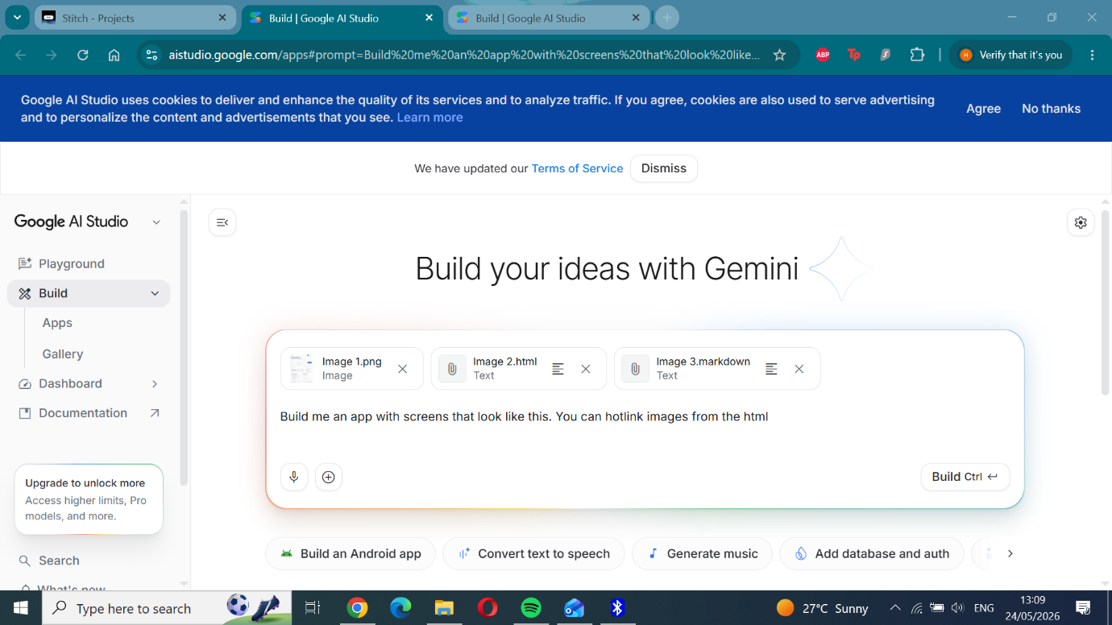
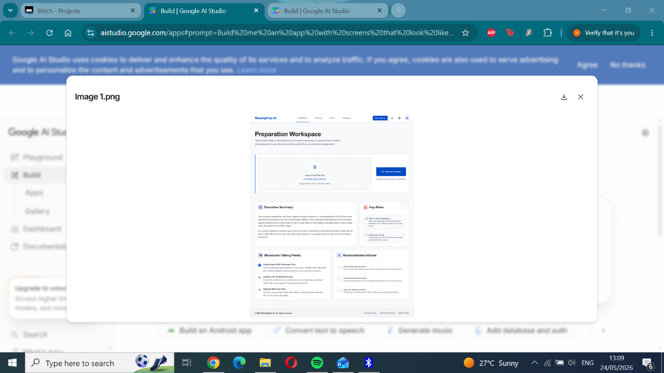
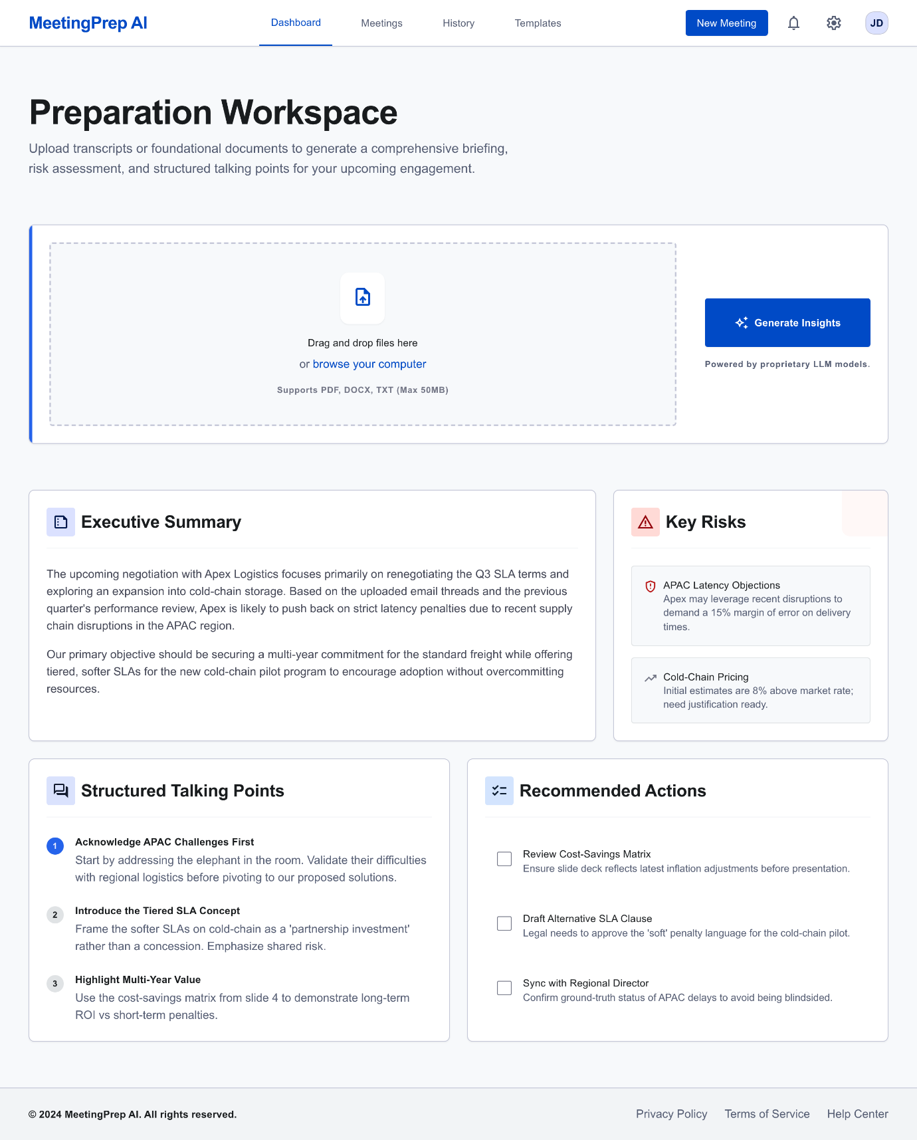
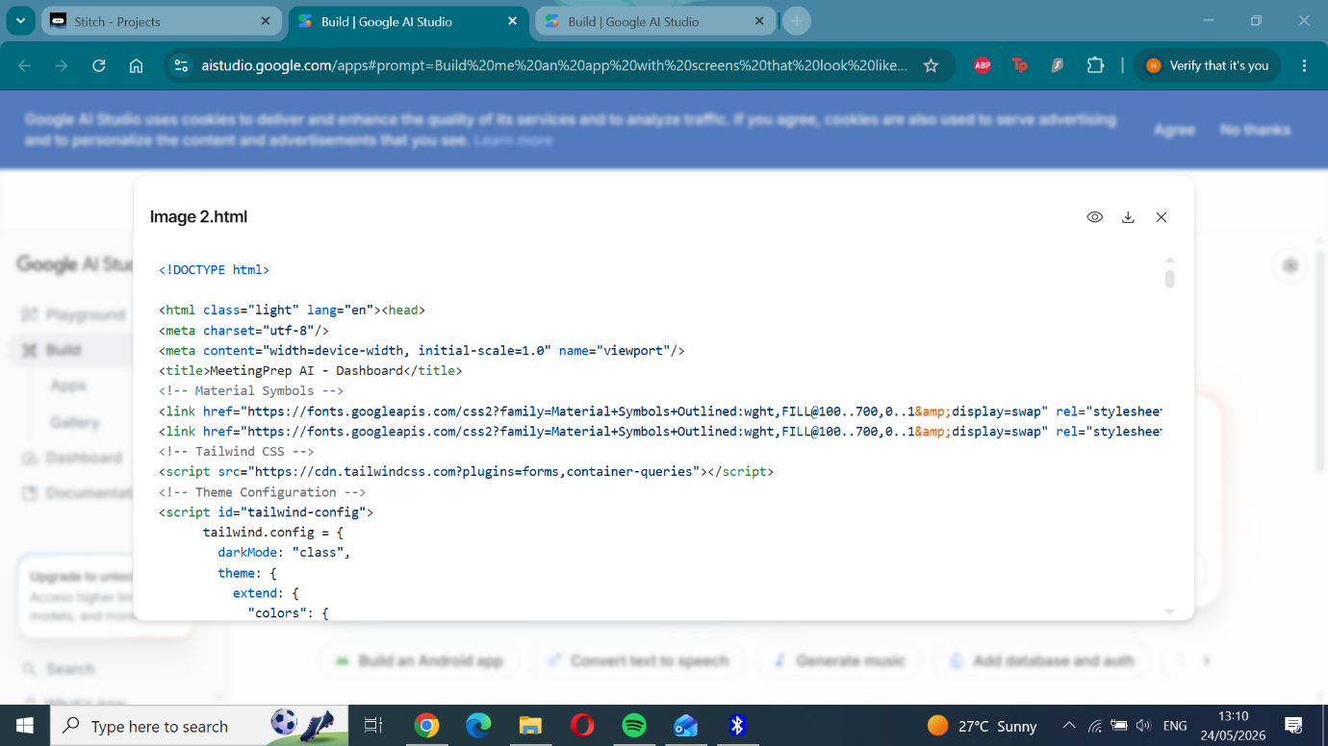
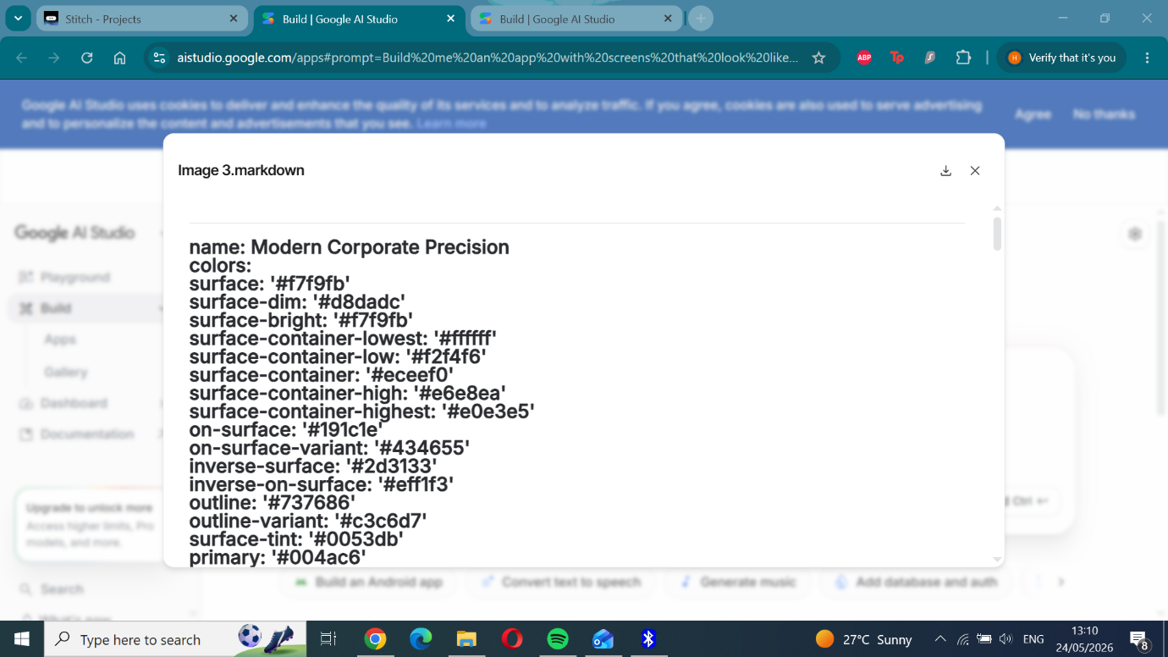

Assignment (architecture and design decisions):
Overview
This project implements a Meeting Preparation Assistant using Google AI Studio and Gemini models via Vertex AI. The system analyses meeting content and generates structured, actionable insights including summaries, risks, talking points, and next steps.
The solution demonstrates prompt engineering, structured outputs, user experience prototyping, and iterative refinement.

Architecture
The system consists of the following components:
- LLM Layer: Gemini 3.1 Pro (Vertex AI)
- Prompt Layer: Structured prompt enforcing JSON output
- UX Layer: Stitch-generated interface screens
- Development Environment: Google AI Studio Agent Builder
- Version Control: GitHub repository

Design Decisions
Model Selection
Gemini 3.1 Pro (Preview) was selected due to its strong reasoning capabilities. This is particularly important for:
- Identifying meaningful risks
- Producing structured JSON outputs
- Generating actionable next steps
Flash models were considered but not used, as they prioritise speed over reasoning quality.

Structured Output Design
A strict JSON schema was enforced to ensure:
- Consistent output format
- Ease of interpretation
- Compatibility for potential downstream systems
This approach improves reliability compared to free-text outputs.

Prompt Constraints
Specific rules were added to control model behaviour:
- Prevent hallucination
- Ensure grounding in provided content
- Maintain clarity and precision
These constraints significantly improved output quality.

Prompt Iterations
Iteration 1
The initial prompt used simple instructions to generate meeting insights.
Observations:
- Output lacked structure
- Risks were often generic
- Some responses were inconsistent
This highlighted the need for stricter formatting and control.

Iteration 2
A structured JSON format was introduced along with grounding rules.
Improvements:
- Output became consistent
- Reduced hallucination
- Clear separation of sections
However, outputs still lacked prioritisation and depth.

Iteration 3 (Final Version)
Additional constraints were introduced to improve output quality:
- Risks include impact levels (High / Medium / Low)
- Talking points are concise and stakeholder-focused
- Next steps are actionable and include ownership
- Output is fully structured and free from repetition
Outcome: The system now produces professional, structured, and actionable insights suitable for real-world use.

UX Design (Stitch)
Stitch was used to generate UI mockups for the Meeting Prep Assistant.
The interface includes:
- File upload functionality
- Insight generation button
- Structured output sections (summary, risks, talking points, next steps)
Stitch enabled rapid prototyping of a clean and professional interface, although it is limited to static outputs.

Advantages:
- Rapid prototyping
- Clean, professional design output
- No coding required

Limitations:
- Limited customisation
- Static outputs (PNG format only)
- No interactive functionality

Testing Approach
Due to platform limitations, file upload functionality was not available within Agent Studio preview mode.
To overcome this, testing was conducted by pasting structured meeting notes directly into the input field.
This approach still enabled:
- Validation of prompt behaviour
- Testing of output structure
- Demonstration of iteration improvements

Future Improvements
To productionise this system, the following enhancements are recommended:
- Integration with document ingestion (PDF and slide parsing)
- API deployment via Cloud Run
- Persistent storage for meeting data
- User authentication and session management
- Feedback loop for continuous improvement

Conclusion
This project demonstrates the effectiveness of iterative prompt engineering in building structured AI applications. Through progressive refinement, the system evolved from producing basic outputs to generating professional, production-ready meeting insights.
The final solution highlights how structured prompts and appropriate model selection can deliver reliable and actionable outputs aligned with business needs.

Reflection
This project demonstrated the importance of structured prompt engineering, iterative refinement, and model selection in building a practical AI application. Through three prompt iterations, the Meeting Prep Assistant evolved from producing basic outputs to delivering structured, actionable insights aligned with real-world business needs.

Prompt Evolution
The development process began with an initial prompt (Iteration 1) that focused on generating meeting insights such as summaries, risks, and next steps. While the outputs were generally relevant, they were inconsistent in structure and often lacked clarity. The model produced free-form responses, with risks appearing vague and some information being loosely inferred. This highlighted the need for stronger constraints to guide output format and reliability.

In Iteration 2, a strict JSON output format was introduced alongside rules to prevent hallucination. This significantly improved consistency, as outputs were clearly segmented into defined categories such as summary, risks, talking points, and next steps. The structured format made the results easier to interpret and more suitable for downstream use. However, the outputs still lacked prioritisation and actionable detail.

Iteration 3 focused on improving the quality and usability of the outputs. Additional constraints were introduced, including assigning impact levels (High, Medium, Low) to risks, limiting talking points to concise stakeholder-ready statements, and ensuring next steps were actionable with ownership fields. These enhancements resulted in outputs that were significantly more structured, precise, and aligned with real-world business expectations.

Model Selection Trade-offs
Model selection played a key role in determining output quality. Flash models were considered due to their speed, but they were not suitable for this use case as they lacked the reasoning depth required for identifying risks and generating structured insights.Gemini 3.1 Pro (Preview) was selected due to its stronger reasoning capabilities. It performed better at interpreting meeting content, generating consistent structured outputs, and identifying meaningful risks and actions. The trade-off was slightly slower response times, but this was acceptable given the improved accuracy and reliability of the outputs.

Use of Stitch for UX Design
Stitch was used to generate UI mock-ups for the Meeting Prep Assistant, enabling rapid prototyping without the need for front-end development. The generated interface included a file upload section, an insight generation button, and structured output areas for summaries, risks, talking points, and next steps. The primary advantage of Stitch was speed and simplicity, allowing for quick generation of clean, professional UI designs. However, it had limitations, including limited customisation and lack of interactivity, as outputs are static images. Despite this, Stitch effectively demonstrated the intended user experience.

Limitations and Challenges
A key limitation encountered was the absence of direct file upload functionality in the Agent Studio preview environment. This was addressed by simulating document input using pasted meeting content. While this did not fully replicate real-world usage, it allowed for effective testing of prompt behaviour and output structure. Another challenge was ensuring that the model consistently adhered to structured output requirements. This was addressed through prompt refinement and the introduction of explicit formatting and behavioural constraints.

Future Improvements
To productionise this system, several enhancements could be implemented:

- Integration with document ingestion pipelines (PDF and slide parsing)
- Deployment as an API using Cloud Run
- Persistent storage for meeting data and outputs
- User authentication and session management
- Feedback mechanisms to iteratively improve output quality

Conclusion
Overall, the project highlights how iterative prompt engineering can significantly improve the performance and reliability of AI systems. By progressively refining the prompt and enforcing structured outputs, the Meeting Prep Assistant evolved into a practical tool capable of generating meaningful and actionable meeting insights.The combination of structured prompt design, appropriate model selection, and rapid UX prototyping demonstrates a scalable approach to building AI-powered applications in a business context.

Github:
